AFRICAN SOLIDARITY CIVIC ORGANISATION NPC (ASCO)
POLICY FRAMEWORK
BOARD-APPROVED POLICY GOVERNANCE — FINAL-FORM DRAFT
FINAL DOCUMENTATION — BOARD APPROVED; EXECUTION / FILING DETAILS TO BE RECORDED
This document records the Board-approved ASCO governance model and policy position. Legal effectiveness, execution, statutory-register updates and filing or registration requirements must be completed by the authorised persons and recorded in the approval register. The Memorandum of Incorporation remains subject to the Companies Act 71 of 2008 and applicable filing requirements.
DOCUMENT CONTROL
Version: 1.0 | Prepared and Board-approved: 10 September 2026 | Resolution reference: To be entered in the approval register | Effective date: To be recorded where applicable | Next review: To be recorded
1. PURPOSE AND AUTHORITY
This Policy Framework establishes the hierarchy, ownership, approval and review process for ASCO policies. The Board of Directors is the approval body unless lawful delegation or the MOI requires another process.
2. POLICY DEVELOPMENT
Policies are drafted by the Executive Director or delegated policy owner, reviewed for legal, operational, safeguarding, financial and privacy implications, and submitted to the Board for approval by recorded resolution.
3. DOCUMENT CONTROL
Every policy must display owner, version, approval authority and resolution, approval date, effective date, next review date and superseded version. A policy cannot be labelled approved without a recorded approval.
4. POLICY REGISTER
Policy | Owner / approval | Review
Conflict of Interest | Board / Board Secretary | Annual declarations; full review 24 months.
Anti-Corruption and Anti-Fraud | Board / Executive Director | 24 months or after incident.
Finance and Procurement | Board / Finance Committee | Annual.
Safeguarding | Board / Safeguarding Lead | Annual.
Complaints and Whistleblowing | Board / designated channel owner | 24 months.
Data Protection and Privacy | Board / Information Officer when designated | 24 months or legal change.
Monitoring and Evaluation | Board / Executive Director | Annual.
Risk Management | Board / Executive Director | Annual.
Donations and Refunds | Board / Finance Committee | Annual.
PAIA Manual | Authorised Information Officer | As required by law and at least annually.

5. PUBLICATION
Approved public policies shall be published in the document library. Internal policies may be marked internal and made available on justified request. Public summaries must not be presented as legal instruments.
6. REVIEW AND EXCEPTIONS
A policy-specific review cycle prevails over a general cycle. Exceptions require Board approval and a recorded rationale.

Place of approval / execution: 49 Rif Road, Manor Gardens, Durban, KwaZulu-Natal, 4001, South Africa
BOARD APPROVAL SIGNATURES
The following signatures are copied from the signed ASCO documents supplied for this purpose. They record Board approval/acknowledgement in the stated capacities; statutory effectiveness, filing and authority remain subject to the applicable approval and filing process.
CHAIRPERSON / FOUNDER  Ms Busisiwe Makhosi Shandu    Date: 6 September 2026  Signature copied from supplied signed document | DIRECTOR: ICT AND COMMUNICATIONS  Mr Thapelo Nelson Maqalika  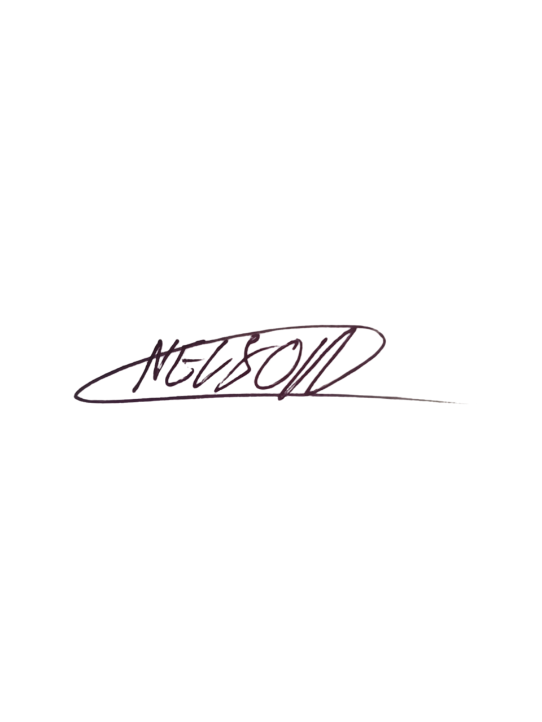  Date: 6 September 2026  Signature copied from supplied signed document
EXECUTIVE DIRECTOR  Mr Bhekisisa Shandu  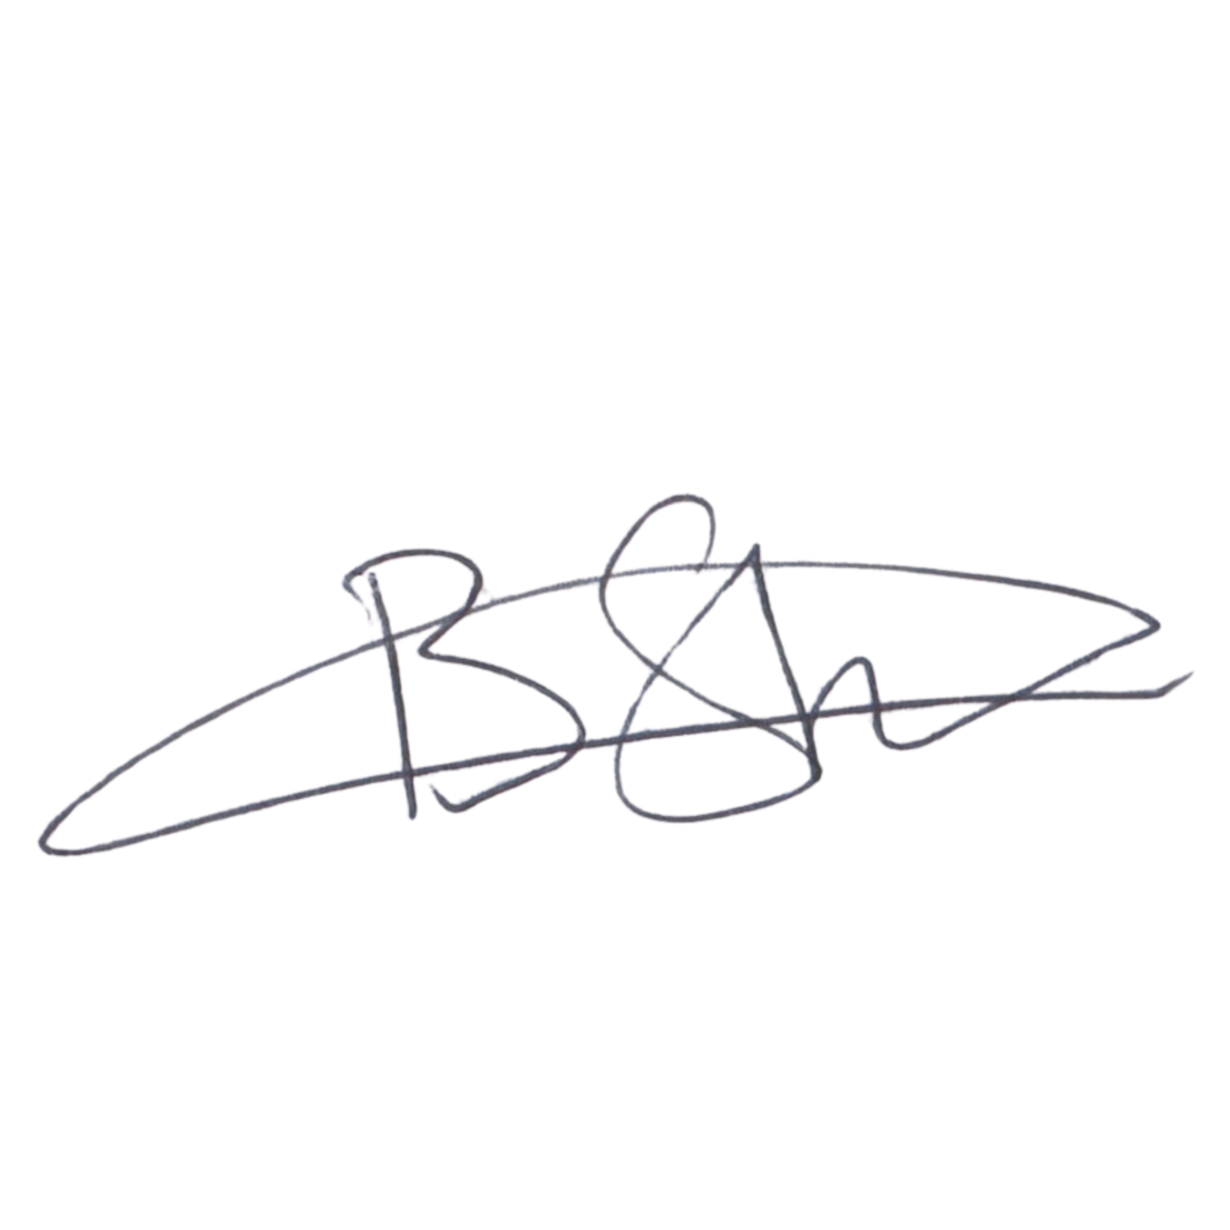  Date: 6 September 2026  Signature copied from supplied signed document | DIRECTOR: PEOPLE AND CULTURE / FINANCE AND PROCUREMENT  Mr Khulekani Gumede  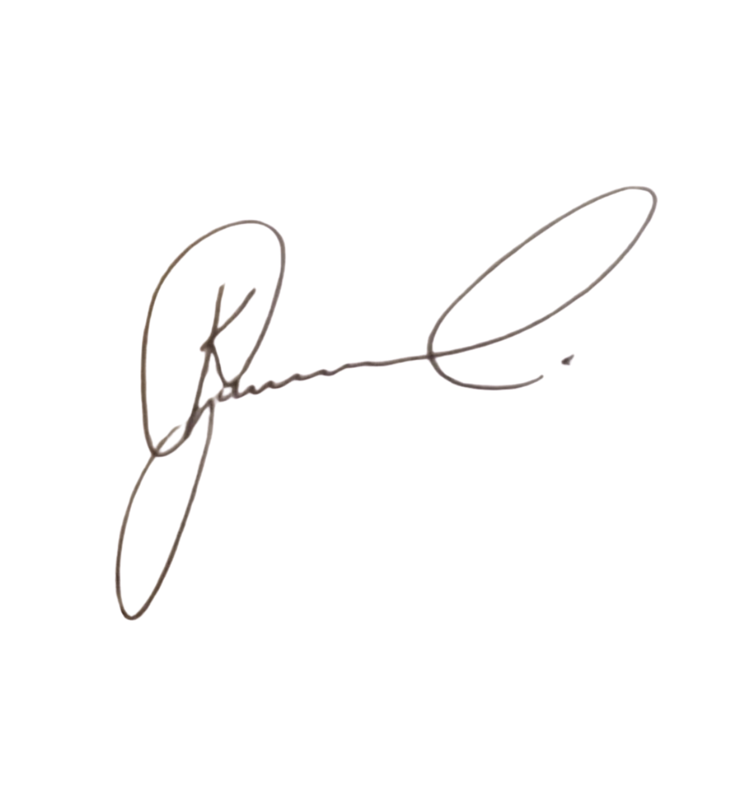  Date: 6 September 2026  Signature copied from supplied signed document

